Problem 1: Select Employee Information

Write a query to select all employees and retrieve information about their id, first_name, last_name and

job_title ordered by id.

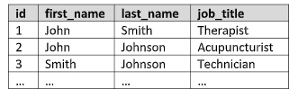

Problem 2: Select Employees with Filter

Write a query to select all employees (id, first_name, last_name, job_title, salary) whose salaries

are higher than 1000.00, ordered by id. Concatenate fields first_name and last_name into ‘full_name’.

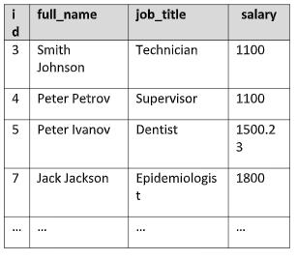

Problem 3: Update Employees Salary

Update all employees salaries whose job_title is “Therapist” by 10%. Retrieve information about all salaries ordered ascending.



Problem 4: Top Paid Employee

Write a query to create a view that selects all information about the top paid employee from the “employees” table

in the hospital database.

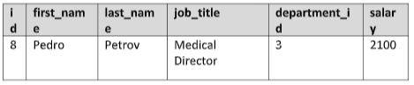

Problem 5: Select Employees by Multiple Filters

Write a query to retrieve information about employees, who are in department 4 and have salary higher or equal to

1600. Order the information by id.

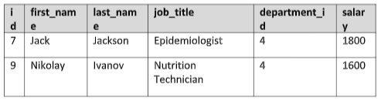

Problem 6: Delete from Table

Write a query to delete all employees from the “employees” table who are in department 2 or 1. Order the

information by id.

